Hello and Welcome from CLAN

When producing our newsletter, we are aware that for many of you, this is the best way to keep in touch. We hope you enjoy getting it posted through your letterbox every month! Remember, if you need help accessing any of the activities, just give us a call. Our CLAN Support Workers are trained Digital Champions and will be happy to help you take part using your laptop or tablet. Not only will you enjoy joining in our online sessions, you may also love connecting online and catching up with friends and family!

Calling all CLAN Volunteers!

Hospice Care Week takes place from 4th-8th October 2021 and we would love to share all the wonderful work our volunteers contribute in helping us to support our patients and carers here at CLAN. We are looking for volunteers to send us pictures of themselves, along with a quote/paragraph about your volunteering role to post on our social media platforms throughout Hospice Care Week. We would also appreciate some good news stories to share with the community regarding all your great work and the people of Lanarkshire whose lives you have touched. If you are interested, please send your pictures or stories to one of our CLAN Support Workers by Friday 10th September 2021. We can also be contacted on 01236 772004.

Sharon.McLoughlin@standrews.scot.nhs.uk
Pauline.McKee@standrews.scot.nhs.uk
Gemma.Russell@standrews.scot.nhs.uk

The Future of Hospice Care in Scotland

The new report from Hospice UK and the Scottish Hospice Leadership Group has given our Hospice Hearty Meals service a glowing report!

St Andrew’s Hospice established ‘Hospice Hearty Meals’ which provides freshly cooked, nutritious two course meals, three days a week, aimed at patients who are isolated with limited support from family and friends. It delivered 579 meals in its first 12 weeks and all respondents rated the service as being excellent. Feedback from patients and carers found the service to be invaluable. It helped relieve the worry and burden of ensuring they ate well, helping them feel less anxious and more able to cope in uncertain times. Due to the success of the project, we applied for further funding which has allowed us to continue with the service and to date we have provided over 1000 meals to patients and carers across Lanarkshire.

Anne is retired and lives alone. She has Parkinson’s disease which has led to reduced mobility and Ataxia. Since lockdown, Anne has received less support and was struggling to make herself fresh, nutritious meals. Since the launch of Hospice Hearty Meals, Anne’s sense of wellbeing has improved: “The meals are absolutely lovely! The menu choice is good, with large portions. This service has improved my health greatly by relieving some of the stresses of lockdown.”

Relaxation Sessions

Thursdays 1.30pm
Unwind, reduce stress and feel calm with our CLAN relaxation sessions on Zoom, which use relaxation techniques and guided visualisation. For further information or if you would like to participate, please contact Pauline on 01236772004 or complete a CLAN enquiry form on our website here: www.st-andrews-hospice.com/patients-and-families/compassionate-lanarkshire/

Mindfulness Resources
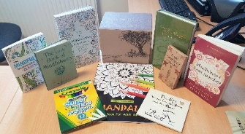
We have a range of mindfulness resources for you, including activity books, colouring books, audio books and many more!

If you enjoy the benefits of mindfulness, join our Outpatient Nurse, Liz, for her online mindfulness sessions on Zoom every week. Mindfulness Mondays take place at 2pm. For further information, please contact Liz on 01236 772004.

Befriending Home Visits Are Back!
CLAN Befrienders – Another way to reach out and stay connected!

Would you like to have a befriender? We will help you identify if you would benefit from regular support from a befriender and match you with one of our volunteers that we think would best suit. Their role is to provide friendship, companionship, support and a listening ear over the telephone or virtually over Zoom, Skype, WhatsApp or Facetime. Home visits have also now resumed for our befrienders (in accordance to Hospice guidelines) for those that wish this.

Could you be a CLAN Befriender?

Befriending makes such a huge difference in communities and in people’s lives. We are looking to recruit more volunteer befrienders, including more male volunteers to provide companionship and a listening ear to those living with a life-limiting illness across Lanarkshire, particularly in Clydesdale in the following areas: Carluke, Lanark and Biggar; also Moodiesburn, Chryston and Stepps. If befriending is something that is of interest to you or someone you know, please get in touch with Jo McIntyre on 01236 772004.

Hospice Harvesters

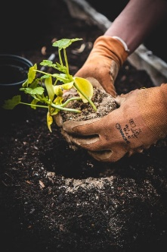
Do you enjoy gardening? Our Outpatient department have a new gardening group called Hospice Harvesters. It takes place here at the Hospice on Mondays from 12.45pm – 2pm in our back courtyard! You can grow fruit, veg and herbs whilst enjoying some friendly chat! This is a drop in service but for more information or to register interest, please contact
Scott on 01236 772004.
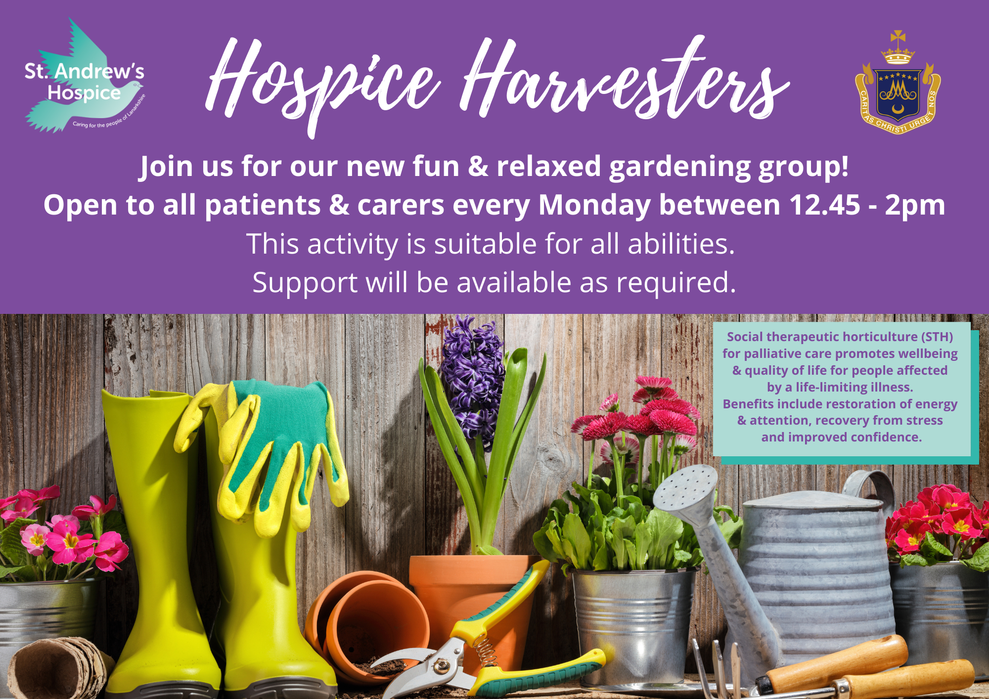

National Balance Awareness Week is
12th -18th September

Strength and balance classes, or falls prevention classes, are designed for people who are unsteady on their feet, are worried about falling or have had a fall. The classes focus on exercise and advice to improve your balance and confidence. This is done by strengthening muscle and bone, improving core strength and stability, and practicing everyday movements until you feel more confident doing them at home. Enquiries can be sent via the following link or ask any healthcare professional you are involved with to make a referral via the Hospice website here:

www.st-andrews-hospice.com/patients-and-families/outpatient-services/make-an-outpatient-referral/

One of our patient’s said recently:
“Keep Moving has shown me how I can improve my balance and every week I feel more confident”
- Strength and Balance class attendee

World Reflexology Week 20th – 26th Sept

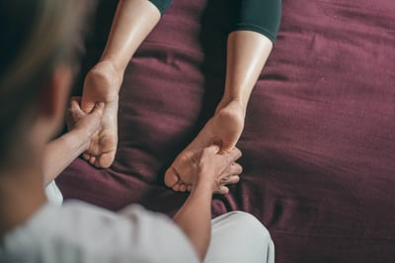
World Reflexology Week takes place annually in the last week of September to promote and raise awareness of the wonderful benefits this therapy can bring. It can improve wellbeing, induce deep relaxation, reduce stress and anxiety, boost mood and aid sleep. First discovered in Ancient China and Ancient Egypt thousands of years ago, the therapist uses their thumbs and fingers to stimulate points on the hands and feet that correspond with parts of the body. Reflexology is just one of the therapies that our CLAN therapists are fully trained and qualified in, and will be offering once again when hospice guidelines allow. Distance therapies are still available and you can contact us anytime with enquiries.

Complementary Therapy Quote

“Over the years, those who I have befriended have really felt the benefits of the complementary therapy treatments offered by the Hospice. One lady found that massage greatly relieved the pain and pressure from very swollen legs. Others have said how Reiki treatments really helped them to relax and sleep better. Relaxation and stress relief techniques were also very much appreciated by a lady who was caring for her terminally ill mother.”
Margot, Volunteer Befriender.

Caring for the People of Lanarkshire

St Andrew’s Hospice
Henderson St
Airdrie ML6 6DJ
Tel: 01236 766951
https://www.st-andrews-hospice.com
Alternatively, you can scan this QR code with your smartphone to access the Hospice website on your phone:

Like us on Facebook facebook.com/StAndrewsHospice1

Follow us on Twitter twitter.com/StAndrewHospice

Follow us on Instagram
instagram.com/standrewshospice

